**Name: Varad Patil**

**PRN: 120A2036**

**EXPERIMENT NO. 06**

**STUDY OF WDM FIBER OPTIC LINK**

**EXPERIMENT NO. 06**

**STUDY OF WDM FIBER OPTIC LINK**

**OBJECTIVE:**

The objective of this experiment is to setup a WDM link with the given components and determine the total loss present in the system for each Wavelength.

**EQUIPMENTS:**

1. C-Band Lasers – 4
2. 4 Channel Mux
3. 4 Channel Demux
4. Optical Power meter

**FORMULA USED:**

If P1 is the optical power of the laser at wavelength λ1 and P2 is the power from the output port of Demux at same wavelength in WDM link then insertion loss is given by the following formula, Insertion Loss = 10 log(P1/P2)

**THEORY:**

Wavelength Division Multiplexing is a technique where optical signals with different wavelengths are combined, transmitted together, and separated again. It is mostly used for optical fiber communications to transmit data in several (or even many) channels with slightly different wavelengths. In this way, the transmission capacities of fiber-optic links can be increased strongly, so that most efficient use is made not only of the fibers themselves but also of the active components such as fiber amplifiers.

**PROCEDURE:**

1. Setup the LIGHT RUNNER as per the instructions given in the manual (Refer figure)
2. Select the corresponding experiment from the experiment drop down menu with the help of stylus and the experiment window will appear on the screen.
3. Now connect all 4 C-band lasers to the respective photodetectors (1510 nm to PD1, 1530 nm to PD2, 1550 nm to PD3 and 1570 nm to PD4) with the help of patch cords.
4. Connect the BNC connector adjacent to PD1 to anyone of the DSO channel with the help of BNC cable.
5. Enable the 1510 nm laser (one lser at a time) by using stylus and set the following parameters:

For example – (a) Frequency = 50 KHz (b) Duty cycle = 50 %

(c) Laser power = 100%

1. Click on the ‘Start’ button, a waveform will appear on the screen corresponding to 1510 nm laser source.
2. In case of detector saturation, reduce the power level below the saturation level and measure the power with the help of optical power meter.
3. Similarly repeat the above given steps from 5 to 7 for other remaining laser also, by enabling them one by one and measure the power of each laser with the help of power meter and note down each laser’s power level as P1.
4. Stop the running experiment by clicking on ‘Stop’ button and disconnect the one end of all the patch cords from photodetectors.
5. Connect the other end of all the patchcords to the respective port of the Mux as shown in the fig. (1510 nm laser to 1510 port..etc)
6. Connect the ‘OUT’ port of the MUX to the ‘IN’ port of the DEMUX.
7. Now connect all the four channels of the DEMUX to the optical power meter one by one and measure the optical power for each of the C-band laser by switching on one laser at a time.
8. Make a note of each laser’s power level as P2.
9. By using the given formula, calculate the insertion loss for each of the channel in WDM link.

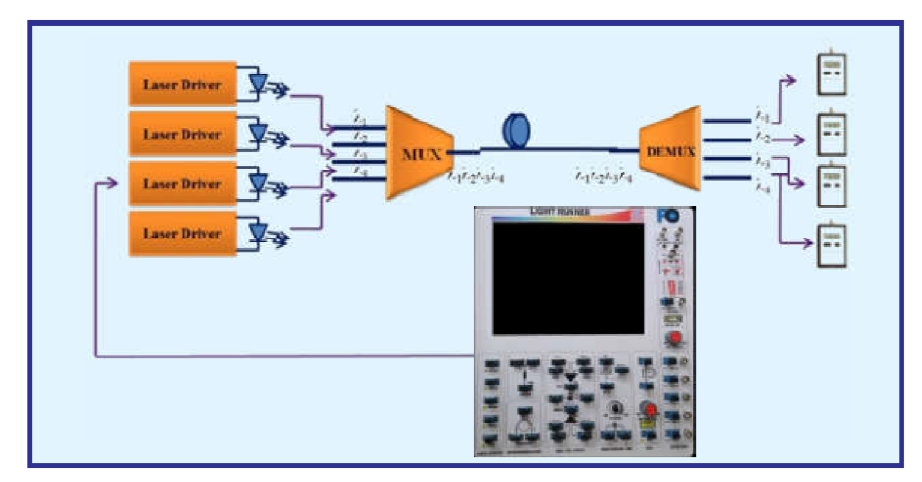

Schematic of the setup of a WDM Link

**OBSERVATION:**

INSERTION LOSS

|  |  |  |  |
| --- | --- | --- | --- |
| Channel  Wavelength (nm) | Input optical power, P1 (µW) | Output optical power, P2 (µW) | Total Loss=10  log(P1/P2) |
| 1510 | 54 | 19 | 2.84 |
| 1530 | 125 | 54 | 2.31 |
| 1550 | 98 | 56 | 1.75 |
| 1570 | 189 | 134 | 1.39 |

**CONCLUSION:**

**When setting up a WDM Fiber Optic we can see that for higher wavelength the total loss is less. Whereas for lower wavelength the loss is more. The experiment was performed successfully.**